ASIA’S LEADING GREEN DESIGN AND GREEN PROJECTS COMPETITIONS ARE BACK!

FuturArc Prize 2019 and FuturArc Green Leadership Award 2019

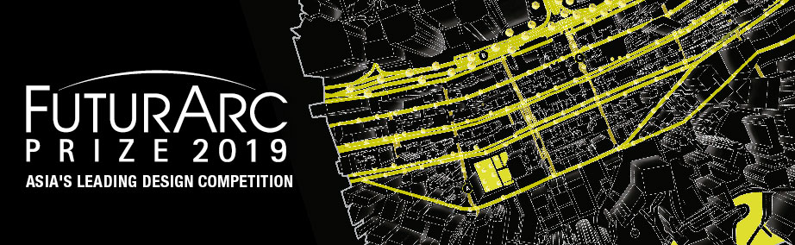

FUTURARC PRIZE (www.futurarcprize.com) seeks forward-thinking, innovative design ideas for Asia. The Competition offers a platform to professionals and students who are passionate about the environment. Through the force of their imagination it aspires to capture visions of a sustainable future.
100,000 people in 1 km2
The FuturArc Prize 2019 asks you to investigate what it means to live in densities of 100,000 per square kilometre.
The redesigned neighbourhood must do the following:
1. Produce energy, water and food
2. Offer inclusive and accessible public space to all groups in the community
3. Offer space to non-human species and perform ecosystem services
4. Engage the wider city in positive and generous way

Site selection is at the entrant’s discretion and should be explained clearly in the submission. Only sites in Asia or Australia will be accepted. Entries should be submitted using templates provided on the competition website.

CASH PRIZES* INCLUDE:
Professional | Student
First Place: S$15,000 | First Place: S$10,000
Second Place: S$8,000 | Second Place: S$5,000
Third Place: S$4,000 | Third Place: S$2,000
(*Prizes subject to changes.)

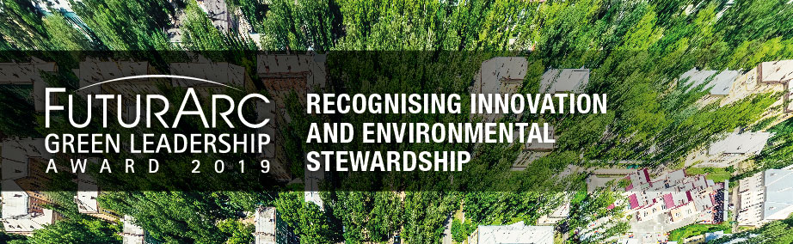

FUTURARC GREEN LEADERSHIP AWARD (www.futurarcgreenleadershipaward.com) seeks innovative and ecologically responsible buildings in Asia. The competition recognises the team behind a completed project: developer, architects, consultants and contractors, who have collectively pushed the limits and definition of what a Green building is in Asia.

The 2019 cycle is looking for Green built projects—defined as new, restored, rehabilitated or converted—that must be completed before 31st December 2018. The project must be located within Asia or Australia.
Entries are invited in six categories:
- Residential – Individual Houses
- Residential – Multiple Houses
- Commercial
- Institutional
- Urban*
- Socially-Inclusive**

*The Urban category includes large projects such as townships or neighbourhoods where the network of space or other urban elements are critical to the functioning of the development. In addition to masterplans, this category can apply to infrastructural developments such as parks, roads, transit systems, etc.

**A Socially-inclusive development is one with a strong social agenda, issues such as social equity, community ties, livelihood, stakeholder involvement through participatory design, etc.

In the case of mixed-use developments (where, for instance, the programme is a mix of commercial and residential), the category selected should reflect whichever is the dominant programme, measured as percentage of total floor area.

The Jury seeks to understand how the project delivers specific outcomes. Entrants must make a case against as many of the following criteria as possible:
- Resilience | Efficacious management of water, energy, materials | Reliance on renewable resources | Cradle-to-cradle approach | Future proofing
- Wellness | Physical, psychological and emotional needs of users | Addressing the aspirations of individuals and communities | Stakeholder engagement
- Embeddedness | Preservation of a sense of community, history and Place | Reliance on local know-how and skills
- Ecosystems | Repair and regeneration of urban or natural systems | Sustainable food production and preservation of nutrient cycles | Protection and enhancement of biodiversity and habitats | Mitigation of climate change
- Replicability | Potential for broad based application | Multiplier effect at the scales of community, precinct or city
Entries should be submitted using templates provided on the competition website.

Regional Recognition

Winners of FuturArc Prize and FuturArc Green Leadership Award will be honoured during BCI Asia Awards ceremony 2019 (May-June 2019), a gala event that attracts the crème de la crème of the architecture, building and construction industry in all seven BCI Asia countries. The total turnout estimates over 2,500. Winners and their winning projects will appear in FuturArc magazine as well as websites and social media channels. FuturArc is the established leading voice of Green architecture and design in Asia, widely distributed in the region.
Competition websites are now open with details on submission requirements and criteria:
www.futurarcprize.com
www.futurarcgreenleadershipaward.com
Closing date for online registration and submission: 31st December 2018.

